c.v.

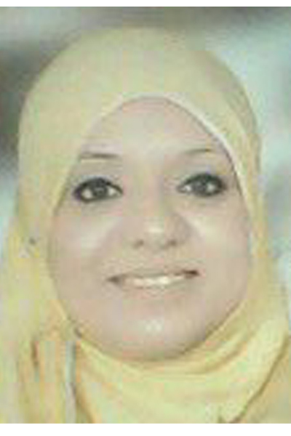
Personal Data

Name: | Rasha Mohamed Kamal Mohamed
Date and Place of Birth: | 27/10/1982, Assiut-Egypt
Nationality: | Egyptian
Institute: | Chemistry Department, Faculty of Science, Assiut University, Assuit, 71516 Egypt
Telephone: | 0020882338321 (Home)  00201003560353 (Mobil)
Current Position: | Assistant Lecturer
Marital status: | Married
Fields of Research: | Physical Chemistry
E-mail: | Rasha_Kamal99@yahoo.com

Education and Academic Qualifications:

2003 : Bachelor of Chemistry, Faculty of Science, Assiut University, Very good with honour grade (84.76%) and 1st on the Chemistry Students.
2003-2008: Demonstrator at Chemistry Department, Faculty of
Science, Assiut University.
2008 until present: Assistant Lecturer at Chemistry Department, Faculty of Science, Assiut University.

Teaching Experience:

- Qualitative Analysis (Identification of simple inorganic salts) for (Science students of 1st year, pre-pharmacy, clinical pharmacy students, Engineering students and Malaysian students).
- Volumetric Analysis (Science students of 1st and 2nd year).
- Practical Physical chemistry (Science students of 3rd year).
- Instrumental Analysis (Students of 4th year).

Studied Courses:

Master ( 2004 – 2005 ):
1-Advanced Electrical Chemistry
2-Advanced Analytical Chemistry
3-Advanced Inorganic Chemistry
4-Molecular Spectroscopy and their applications
5-Optional Course
6-Computer Science and Statistics
7-Practical Course

Career Objectives:
My short-term career objective is to obtain admission for graduate level studies for Ph.D degree in physical chemistry and to conduct original research in advanced and modern application in relevant field.
My long-term objective is to obtain substantial experiences and expertise by working as a research chemist.

List of Publication:
2008: Participated in a conference for young Scientists Basic Science and Technology (oral) October 2008, Assiut, Egypt.
2014: Participated in international conference for young Scientists Basic Science and Technology April 2014, Assiut, Egypt, (I won with the best poster prize).

Research Interests:
My research interests lie within the Inorganic and Physical Chemistry.
I am interested in studies of catalytic activities of metal oxides, synthesis of nanocrystalline of metal oxides and development of new chemical catalyst agents.

Language Proficiency:

Arabic: Mother Tongue.
English: good

